Experiment 10

# Student Name: Rahul Maurya UID: 20BCS7260

**Branch: CSE Section/Group: PH20BCS716-B**

**Semester**:**4th Date of Performance**:**20-04-2022**

**Subject Name: MPI lab**

# Aim/Overview of the practical:

**Write8085 Assembly language program to add two 16-bit number stored in memory location 8000H – 8001H and 8002H – 8003H .**

1. **Apparatus/Simulator used**

# JUBIN

* **JAVA**

# Description/Code:

**# BEGIN 0000H**

**LHLD 8000H**

**XCHG**

**LHLD 8002H**

**MVI C,00**

**DAD D**

**JNC AHEAD**

**INR C**

**MOV A,C**

**STA 8004**

**AHEAD: SHLD 8004**

**HLT**

**# ORG 8000**

**# DB 06H,04H,12H,03H**

**5. Result / Output / Writing Summary:**

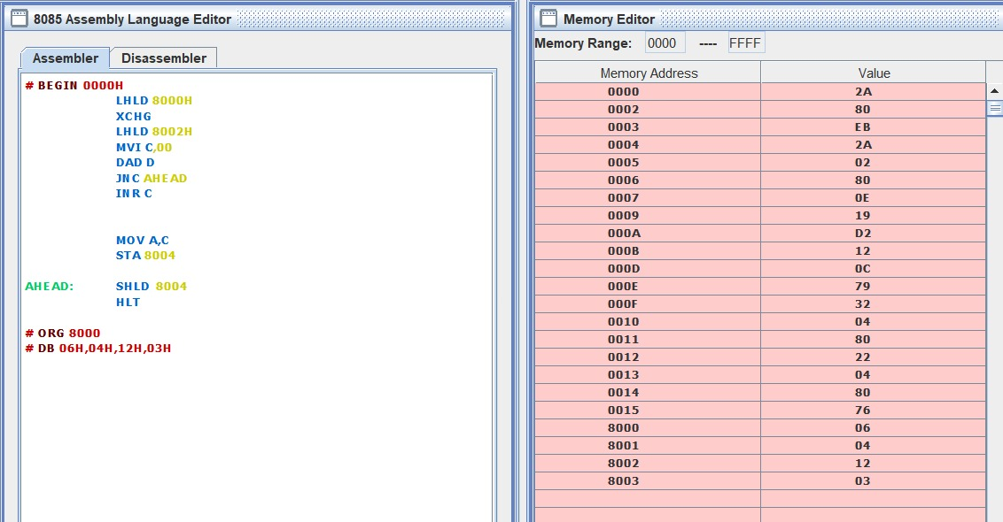

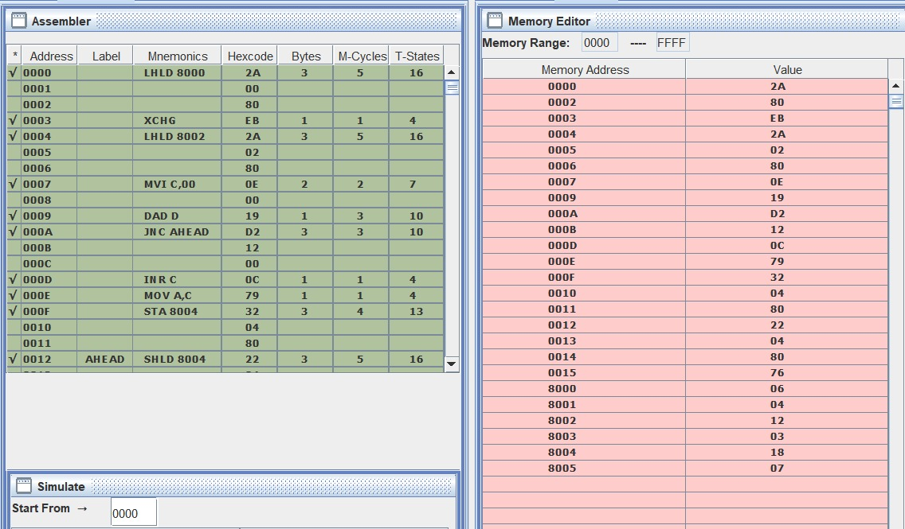

**6. Learning outcomes (What I have learnt):**

* Working of microprocessors.
* Learn how to do mathematical operations in microprocessors.
* Learn about 8085simulator.
* Operations of 8bit numbers.
* Learn about the different instructions that are needed to be given to the memory to perform some tasks.